Electrolysis

1. Electrolysis- forcing a current through a cell to produce a chemical change. Current must be forced because the process is not spontaneous. This is the opposite for galvanic cells.

2. Similarities and Differences between Galvanic Cells and Electrolytic Cells

Electrolytic Cell | Galvanic Cell
Reduction at Cathode | Reduction at Cathode. The more positive standard reduction potential belongs here.
Oxidation at Anode | Oxidation at Anode
Cathode is negative | Cathode is positive
Anode is positive (E.P.A – electrolytic positive anode) | Anode is negative
Usually in a single container | Never is a single container
E_{cell} is negative | E_{cell} must be positive
Needs a battery | Is a battery
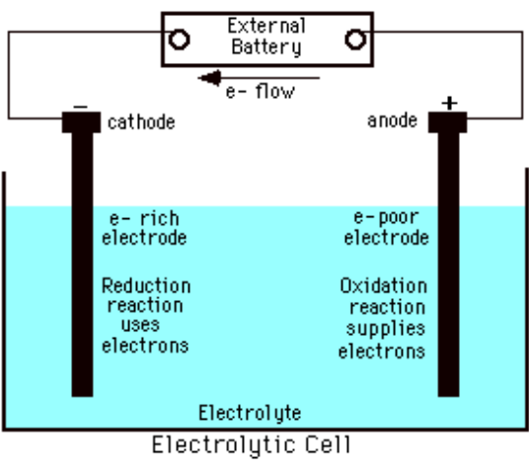
3. Uses of Electrolysis
a. Charging a battery.
b. Producing aluminum metal.
c. Plating a metal – silverplating jewelry or silverware.

4. Quantitation of the chemical change occurs when the current is supplied. (aka- how much silver can you get on that nickel metal to fool your girlfriend into thinking that bracelet is the real deal.)

a. Faraday’s Law: The amount of a substance being oxidized or reduced at each electrode during electrolysis is directly proportional to the amount of electricity that passes through the cell.

b. Stoichiometry of Electrolytic Processes
Step 1 – convert current and time to quantity of charge in coulombs
a. 1 Ampere = 1Coulomb 2 Amperes = 2 Coulomb
1 second 1 second
Step 2 – convert quantity of charge in coulombs to moles of electrons
1 mole electrons = 1 faraday = 96,485 coulombs
Cu⁺² needs 2 moles of electrons to become an atom
Ag⁺ needs 1 mole of electrons to become Ag

Step 3 – Convert moles of electrons to moles of substance
Mol e- X mole substance = mol substance
Mole e-
Step 4 – Convert moles of substance to grams of substance
Mol substance X formula mass of substance = mass of substance

Current and Time
Quantity of charge
Moles of electrons
Moles of element
Grams of element

Exercise 9
How long must a current of 5.00 A be applied to a solution of Ag⁺ to produce 10.5 g silver metal?

= 31.3 min

5. Electrolysis of Mixtures of Ions- The more positive the E°, the more likely the reaction has a tendency to proceed in that direction. Look at the standard reduction potentials.
Reduction – more positive goes first
Oxidation – less negative goes first

Exercise 10
An acidic solution contains the ions Ce⁴⁺ , VO₂⁺ , and Fe³⁺ . Using the E° values below, give the order of oxidizing ability of these species and predict which one will be reduced at the cathode of an electrolytic cell at the lowest voltage.

The half reactions and E° are:

Ce⁴⁺ + e- → Ce³⁺ E° = 1.70V
VO²⁺ + 2H⁺ + e- → VO²⁺ + H2O E° = 1.00 V
Fe³⁺ + e- → Fe²⁺ E° = 0.77V

Ce⁴⁺ > VO₂⁺ > Fe³⁺

6. Predicting the Products of Electrolysis:
a. If there is no water present and you have a pure molten ionic compound, then:
i. the cation will be reduced (gain electrons/go down in charge)
ii. the anion will be oxidized (lose electrons/go up in charge)
b. water is present and you have an aqueous solution of the ionic compound, then:
i. you’ll need to figure out if the ions are reacting or the water is reacting. You can always look at a reduction potential table to figure it out but, as a rule of thumb:
a. no group IA or IIA metal will be reduced in an aqueous solution – water will be reduced
instead.
b. no polyatomic will be oxidized in an aqueous solution water will be oxidized instead.
c. Half Reactions for the electrolysis of water: (must memorize!)
If Oxidized: 2 H₂O → O₂ + 4 H⁺ + 4e- E° = -1.23 V
If Reduced: 2 H₂O + 2e- → H₂ + 2 OH⁻ E° = -.83V
Summary
Cathode = highest E_{red} value
Anode = lowest E_{red} value

Therefore,
i) Na⁺, Ca²⁺ and Al³⁺ have lower reduction potential than water so H₂ gas is evolved at the cathode.

ii) Cu^{2+,} Ag⁺ have much higher reduction potential than that of water. So these ions are deposited at the cathode.

c. Examples
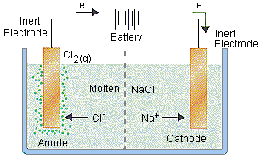
1. Molten ionic compound – Two inert electrodes are inserted into molten NaCl and connected to a source of direct current. Write the cell reaction.

Na⁺ + Cl⁻ are in the cell.

The DC battery pulls electrons from Cl- and forces them onto Na⁺.
2(Na⁺ + 1e⁻ → Na) reduction cathode
2Cl⁻ → Cl₂ + 2e- oxidation anode

2Na⁺(l) + 2Cl⁻(l) → 2Na(l) + Cl₂(g)

2. Aqueous solution of ionic compound
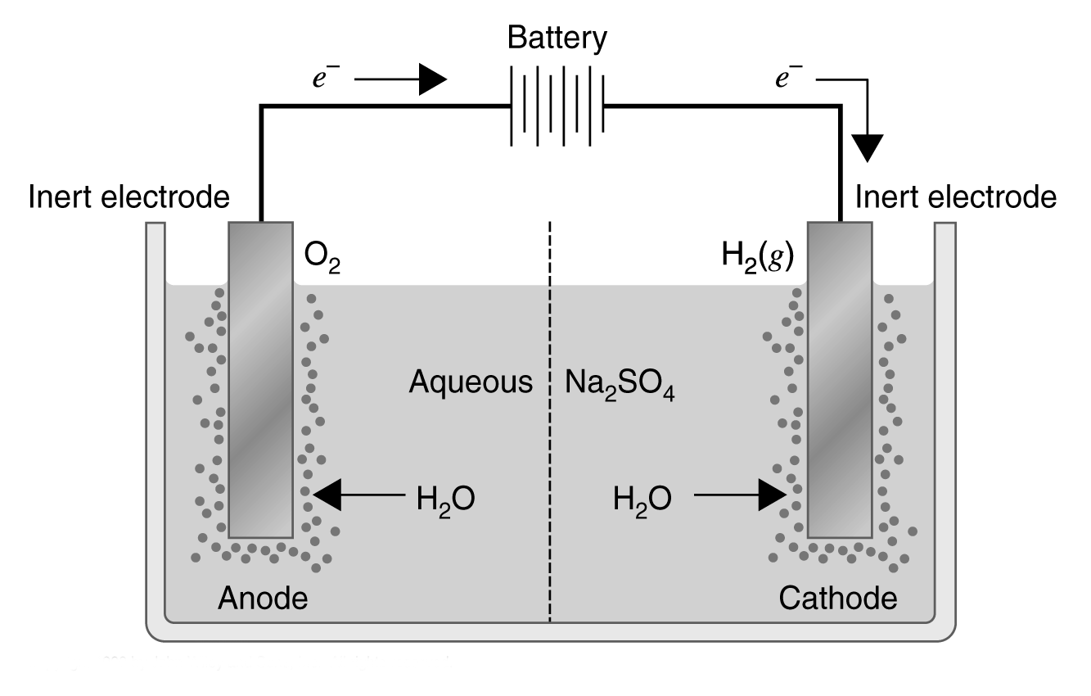
Cation
Na⁺ + e- → Na E° = - 2.71V
2H₂O + 2e- → H₂ + 2OH- E° = -.83 V
Water will be reduced at the cathode

Anion
Same thing occurs, it is easier to oxidize the water than the sulfate, Therefore: 2 H₂O → O₂ + 4 H⁺ + 4e-

Electrolysis is planned for an aqueous solution that contains a mixture of 0.50M ZnSO4 and 0.50 NiSO4. On the baisis of standard reduction potentials, what products are expected to be observed at the electrodes? What is the expected net cell reaction?

